**Lab Administering Users and Security in Oracle**

In this Lab, you use Enterprise Manager to create a role and two users.

1. Log in as the SYS user with a SYSDBA connection.
2. You are going to create the Hospital Manager (steps to follow are below) user with the following characteristics:

Username: HOSPMGR

Password: HOSPMGR

Temporary tablespace: TEMP

Default tablespace: USERS

Status: Unlocked

[Note TEMP and USERS tablespaces were created when you originally installed the database]**.**

**a.** In Enterprise Manager, navigate to Server>Security>Users and Click Create.

**b.** Enter HOSPMGR in the Name field.

**c.** Select the default profile and password authentication.

**d.** Enter HOSPMGR in the Enter Password and Confirm Password fields.

**e.** Enter USERS in the Default Tablespace field.

**Hint:** Click the flashlight icon for a list of available tablespaces.

**f.** Enter TEMP in the Temporary Tablespace field.

**g. Status –** Remain as unlocked

**EXERCISE**: Before clicking OK, examine make a note of the SQL that has been generated

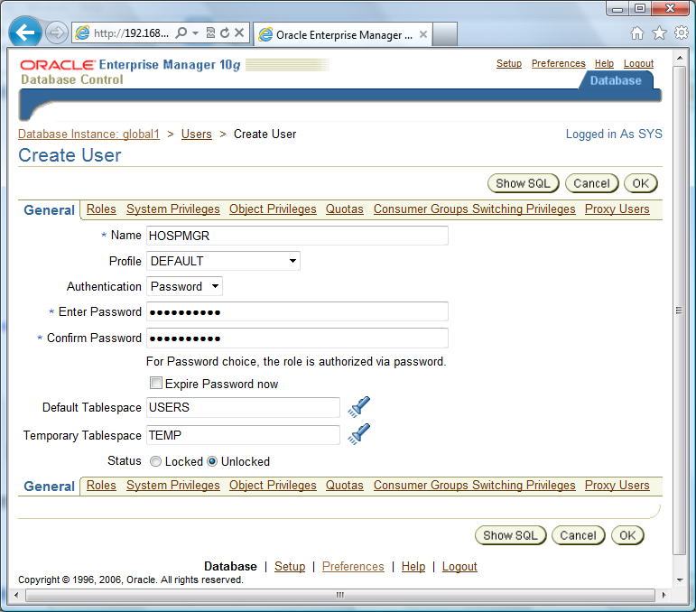

|  |
| --- |
| **Insert the SQL here:**  **CREATE USER "HOSPMGR" PROFILE "DEFAULT" IDENTIFIED BY "*******" DEFAULT TABLESPACE "USERS" TEMPORARY TABLESPACE "TEMP" ACCOUNT UNLOCK**  **GRANT "CONNECT" TO "HOSPMGR"** |

**Reminder –** Make sure you clicked OK to save these changes.

1. Next you will grant the CREATE SESSION and CREATE TABLE system privileges to the hospital manager owner by following the steps below:

**a.** Select the user from the list of users displayed after the previous practice. Click Edit, System Privileges, and then click Edit List.

**b.** Scroll down the list of available system privileges until you find CREATE SESSION and CREATE TABLE. Use the arrow button to move them to the Selected System Privileges. **NOTE:** DO NOT select the Create **ANY** options.

**c.** Click OK.

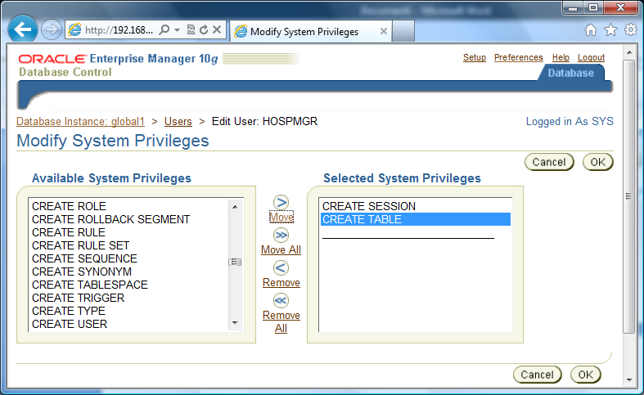

1. Next we will grant quota on the USER and TEMP tablespaces to the hospital manager.

Click Quotas.

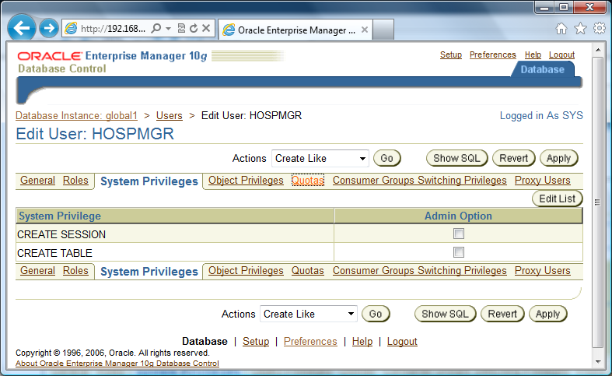

**b.** Find the USERS tablespace and select Unlimited from the Quota drop-down list or enter –1 in the Value field. Choose the SHOW SQL command and paste what you get in the box below.

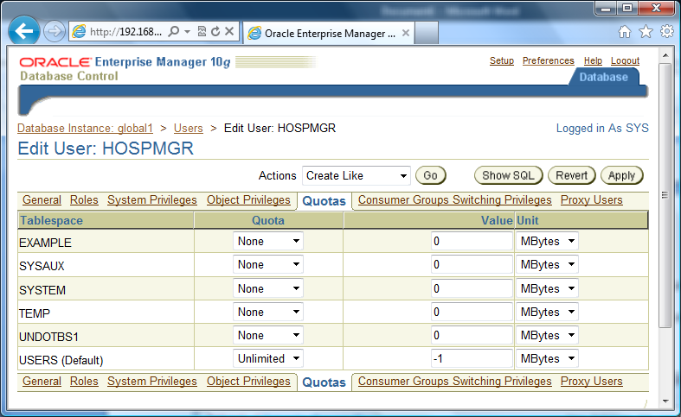

**Insert the SQL here:**

**CREATE USER "HOSPMGR" PROFILE "DEFAULT" IDENTIFIED BY "*******" DEFAULT TABLESPACE "USERS" TEMPORARY TABLESPACE "TEMP" QUOTA UNLIMITED ON "USERS" ACCOUNT UNLOCK**

**GRANT CREATE SESSION TO "HOSPMGR"**

**GRANT CREATE TABLE TO "HOSPMGR"**

**GRANT "CONNECT" TO "HOSPMGR"**

**c.** Click return to get out of the Show SQL and then click OK to assign the quota to HOSPMGR.

1. Next you will grant Enterprise Manager administrative privileges to the HOSPMGR user. Effectively, this user will then have full rights to manage the database. Follow the steps below:
2. Return to the main Enterprise Manager page by clicking on the database tab on the top right hand side.
3. Click Setup from the links at the top of the Database Control page.

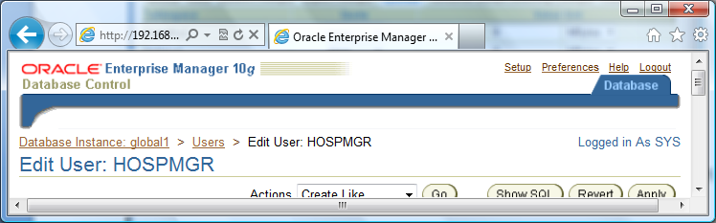

You will see the following screen:

On this screen you choose the Administrators option form the left hand menu and you will see the following

g screen:

Click on **CREATE** on the above Screen. And you will get the screen below:

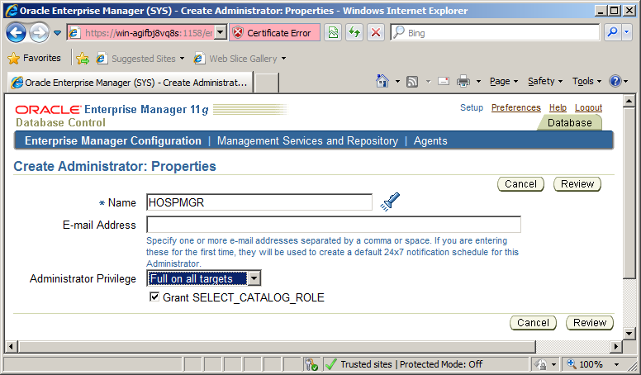

**c.** Enter HOSPMGR in the Name.

**d.** Leave Email Address blank and choose **Super Administrator**, by choosing the *Full on all targets* option from the drop down**,** for Administrator privileges.

**e.** Click Review. On this Review screen read the Description beside the FULL ANY TARGET and explain this below.

**Insert the answer here:**

**Full target privilege on all available targets in the system.**

**f.** Click Finish again to grant administrative privileges to

HOSPMGR. Include this final screen to show the Administrator access has been added to HOSPMGR.

**Insert the screen shot here:**

1. Now Logout and Log in to Enterprise Manager as the HOSPMGR user (you are currently SYS) and connect as normal (not sysdba).

Click Tables under Schema>Database Objects> Tables.

**6a.** You will now create an EMPLOYEES table in the USERs tablespace, as per instructions below:

1. Click Create.

1. Select “Standard, Heap Organized” and do not select Temporary. Click Continue.

**b.** Enter EMPLOYEES in the Name field, HOSPMGR in the Schema field, and USERS in the Tablespace field.

**c.** Enter column specifications as shown below (you will have to add five table columns):

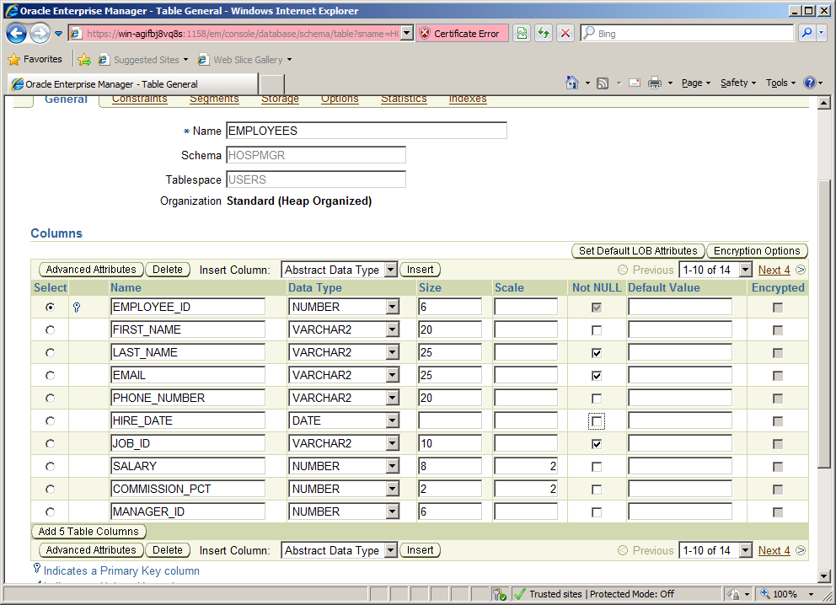

**6b.** Define a PRIMARY KEY constraint on the EMPLOYEE_ID column.

1. Click Constraints.

**b.** Select Primary and click Add.

**c.** Enter EMPLOYEES_ID_PK in the Name field.

**d.** Use the arrow button to move EMPLOYEE_ID from the Available Columns list to the Selected Columns list.

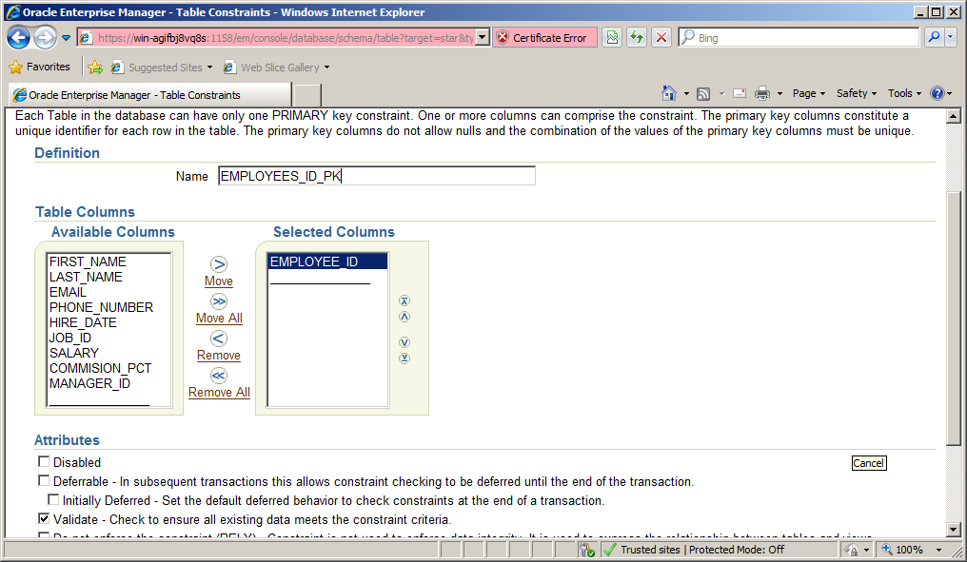

**e.** Select the Validate attribute.

**f.** Click Continue to create the constraint.

**g.** Click the Show SQL and add what is displayed in the box below:

Insert SQL here:

**CREATE TABLE "HOSPMGR"."EMPLOYEES" ( "EMPLOYEE_ID" NUMBER(6) NOT NULL , "FIRST_NAME" VARCHAR2(20), "LAST_NAME" VARCHAR2(25) NOT NULL , "EMAIL" VARCHAR2(25) NOT NULL , "PHONE_NUMBER" VARCHAR2(20), "HIRE_DATE" DATE, "JOB_ID" VARCHAR2(10) NOT NULL , "SALARY" NUMBER(8), "COMMISSION_PCT" NUMBER(2), "MANAGER_ID" NUMBER(6), PRIMARY KEY ("EMPLOYEE_ID") VALIDATE ) TABLESPACE "USERS"**

Explain this SQL in your own words.

**Student needs to detail what the code above does.**

**h.** Click Return and then OK to create the table.

**This is the table details of what we have created above. It currently has no data in it.**

|  |  |
| --- | --- |
| EMPLOYEE_ID NUMBER(6) | HIRE_DATE DATE |
| FIRST_NAME VARCHAR2(20) | JOB_ID VARCHAR2(10) |
| LAST_NAME VARCHAR2(25) | SALARY NUMBER(8) |
| EMAIL_ADDRESS VARCHAR2(25) | COMMISSION_PCT NUMBER(2) |
| PHONE_NUMBER VARCHAR2(20) | MANAGER_ID NUMBER(6) |

Choose the **view data** option on the action menu to see the data.

This can take a few minutes so if it’s not there move on and check it in about 10 mins. If it does not work go to the end of the lab for an alternative option. Ensure the data is loaded in some form before continuing.

1. We now are going to add data to this table using a Enterprise Manager Tool called the data loader.
2. Go to moodle and download the emp.dat file.
3. On the VM go to the desktop and go to the menu and choose Applications>Accessories>Text Editor
4. Go back to your machine and copy the contents of the emp.dat file and paste them into the new text file on the VM. Save this to the **Desktop.**
5. If you find yourself in the unfortunate position where the copy does not work you need to recreate the file (exactly as it appears) into the VM. Replicate the first line, copy and paste this 11 times and just make the changes to replicate the file. Save this to the **Desktop.**
6. Once you have the file copied over then click Load Data from Data Movement> Move Row Data> Load data from user files

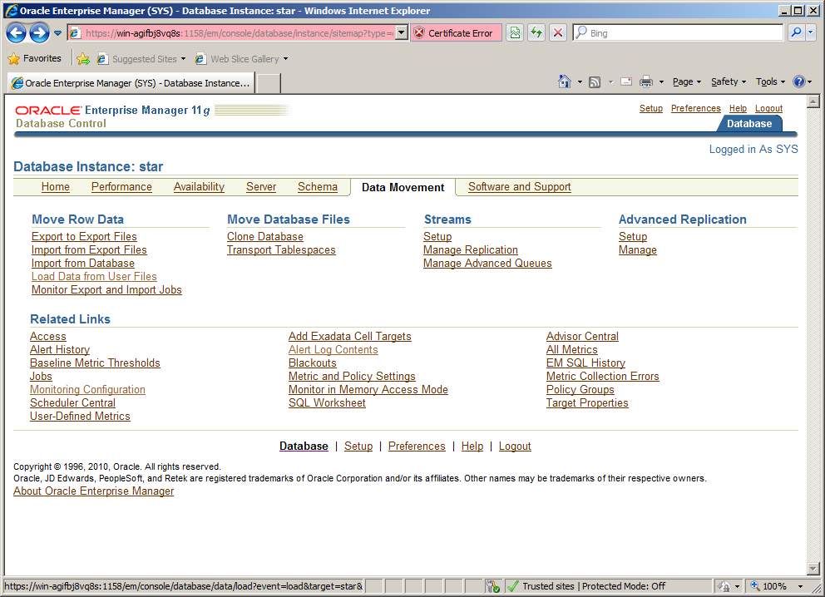

1. Choose **Automatically Generated Control File** and username and password is **oracle** and **oracle**. Click Continue

|  |
| --- |
|  |

1. ChooseData File is Located on **Browser Machine** and browse to your emp.dat file (On the desktop). Add the temporary file location as below. lick Next

1. Type in HOSPMGR.EMPLOYEES as the table name as below. Click Next

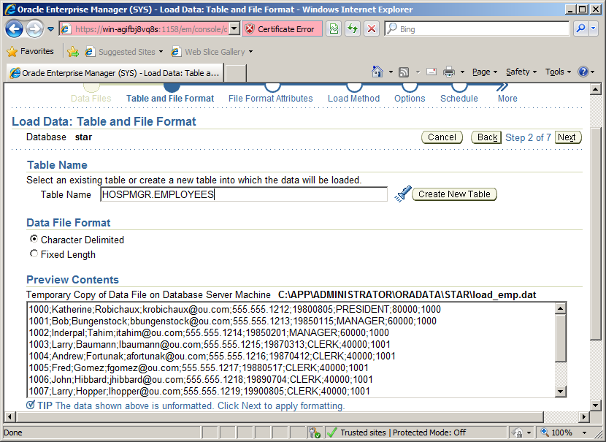

1. Change the field indexes as below follows. Also character Delimiters need changing. Change Field Delimiter entry to ;and remove **“** from Field Enclosure text box. After that scroll down the page and Click on the File Format attributes. When the data is satisfactorily displayed, click Next

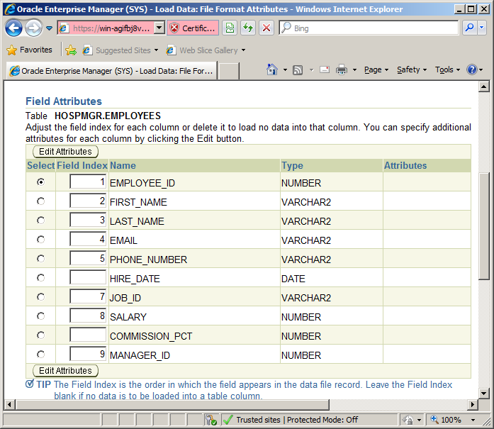

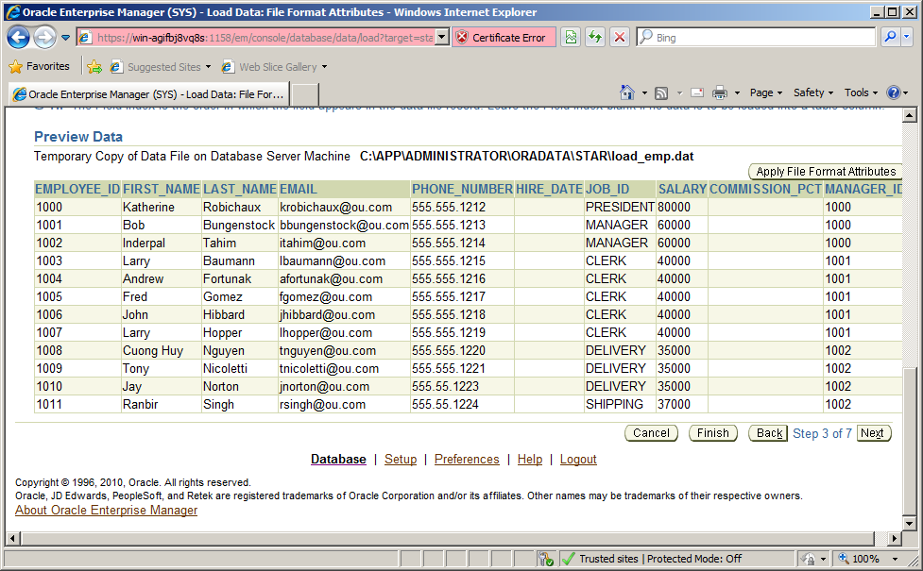

Click Next

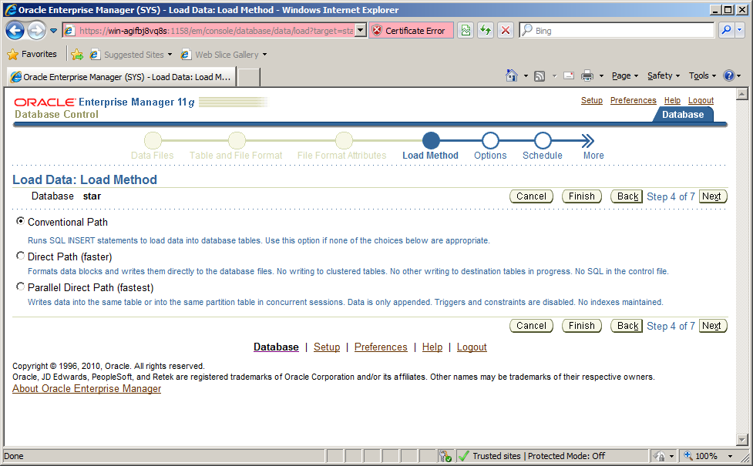

Click Next

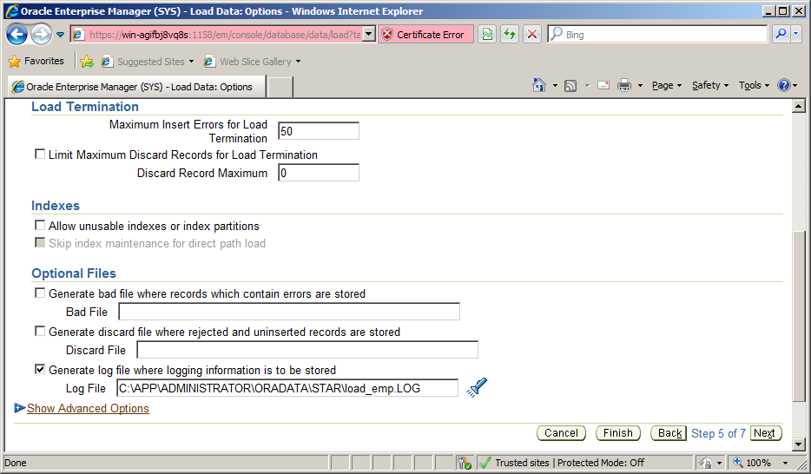

Click Next

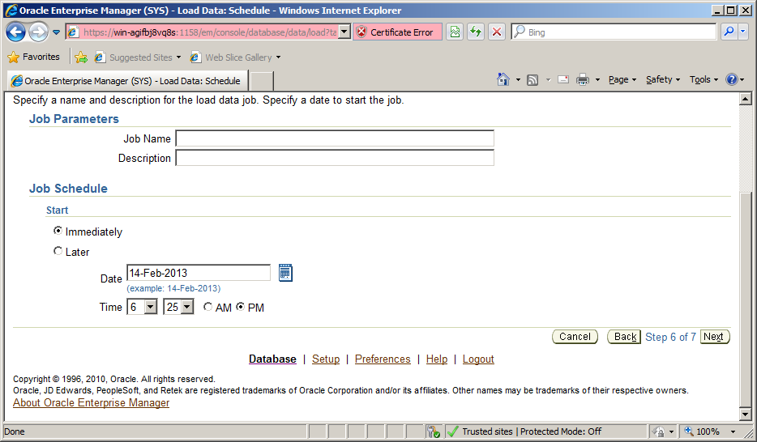

Click Submit Job.

Show screen shot of success here:

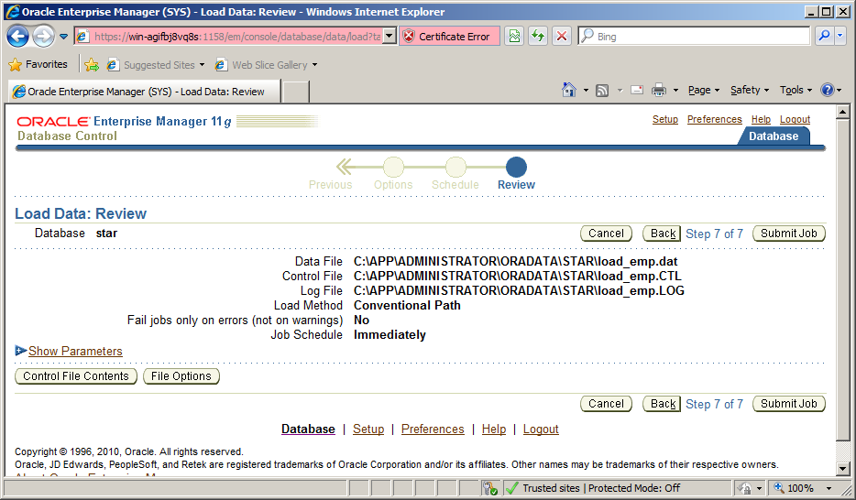

When complete, Return to Database>Schema>tables and check and see did the data load into the table.

Choose the **view data** option on the action menu to see the data.

This can take a few minutes so if it’s not there move on and check it in about 10 mins.

Next logout and login Login as SYS and create a role for the hospital clerk named HOSPCLERK with the CREATE SESSION privilege:

**a.** Click Roles in the Server>Security>Roles

**b.** Click Create and enter HOSPCLERK in the Name field, and then select None from the Authentication drop-down list.

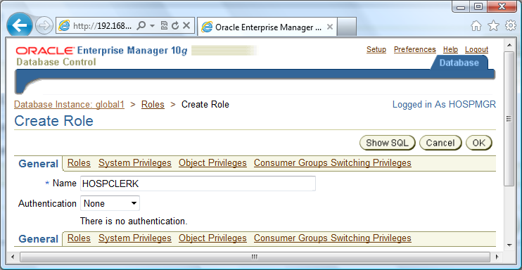

**c.** Click System Privileges, and then click Edit List.

**d.** Scroll down the list of available system privileges until you find CREATE SESSION. Use the arrow button to move it to the Selected System Privileges.

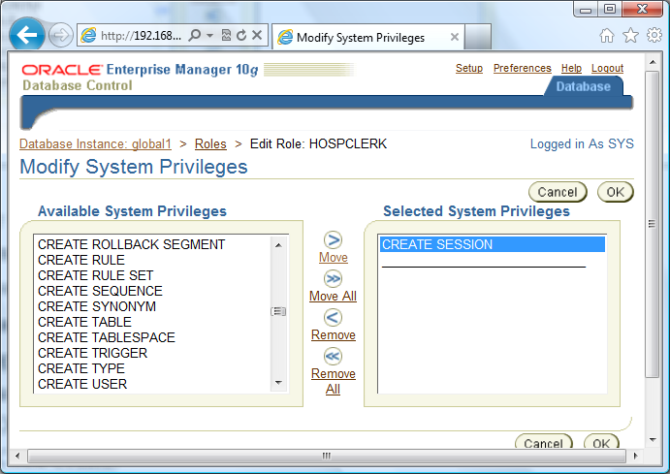

**e.** Click OK, and Show SQL

Insert SQL here:

**CREATE ROLE "HOSPCLERK" NOT IDENTIFIED**

**GRANT CREATE SESSION TO "HOSPCLERK"**

f. Then click return and OK again to create the role.

**g.** Let us give this role some object privileges on an existing table in the HOSPMGR schema.

Click on HOSPCLERK in the list and choose edit.

Then choose object privileges and the screen below appears.



Choose the TABLE option from this drop down box and click ADD.

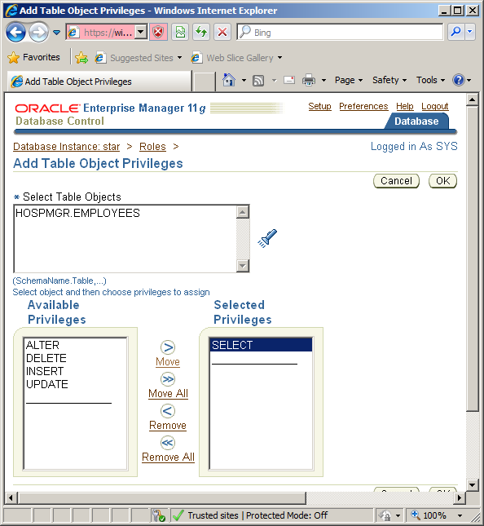

Click APPLY when finished.

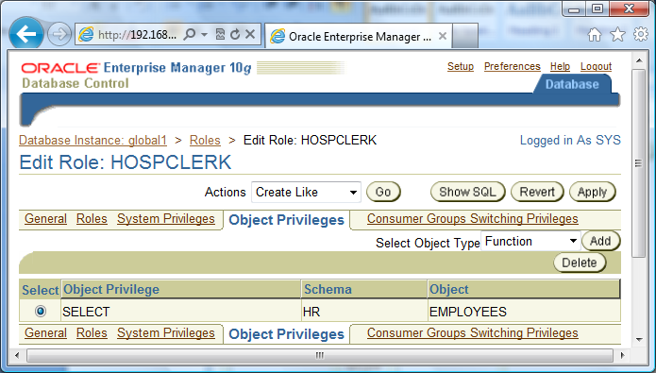

1. Create a hospital clerk user with the following characteristics:

Username: JOECLERK

Password: JOECLERK

Default tablespace: USERS

Temporary tablespace: TEMP

Status: Unlocked

What is the SQL that is generated?

|  |
| --- |
| **Answer:**  **CREATE USER "JOECLERK" PROFILE "DEFAULT" IDENTIFIED BY "*******" DEFAULT TABLESPACE "USERS" TEMPORARY TABLESPACE "TEMP" ACCOUNT UNLOCK**  **GRANT "CONNECT" TO "JOECLERK"** |

1. After Creating JOECLERK let us now give him the HOSPCLERK role. Click on roles and assign the HOSPCLERK role to JOECLERK.

Provide the SQL and Screen Shot on how you added the role.

|  |
| --- |
| **Answer:**  **GRANT "HOSPCLERK" TO "JOECLERK"**  **ALTER USER "JOECLERK" DEFAULT ROLE ALL** **Click on roles, edit roles and then look for hospmgr role and add this.** |

1. Login as JoeClerk using SQLPLUS\iSQLPLUS and test that he has only query access to the EMPLOYEE table in question. Provide the SQL you used as well as Oracle messages

|  |
| --- |
|   Here one option is DELETE joe does not have the privileges to do this. Error below. Student can provide insert/update or delete here.** |

**ALTERNITVE TO STEP 7 ABOVE**

Go to moodle and download the empfile.sql.

Copy this into the SQL DEVELOPER on the VM (make sure you are logged in as HOSPMGR in SQL developer)

Run the script and go to the EMPLOYEES table in the OEM and ensure that the data is now loaded as below:

